**EXPERIMENT – 2**

**EXP NO 2: CREATE A SIMPLE CLOUD SOFTWARE APPLICATION FOR FLIGHT RESERVATION SYSTEM USING ANY CLOUD SERVICE PROVIDER TO DEMONSTRATE SAAS.**

**DATE:**26/09/25

**AIM:**

To create a simple cloud software application for flight reservation system using

any cloud service provider to demonstrate saas.

**PROCEDURE:**

**step1:** Go to zoho.com.

**step 2:** Log into the zoho.com.

**step 3:** Select one application step.

**step4:** Enter application name as flight reservation system.

**step 5:** Created new application flight reservation system.

**step 6:** Select one form

**step 7:** The software has been created.

**OUTPUT:**

**FORM 1 –Flight Searches Form**

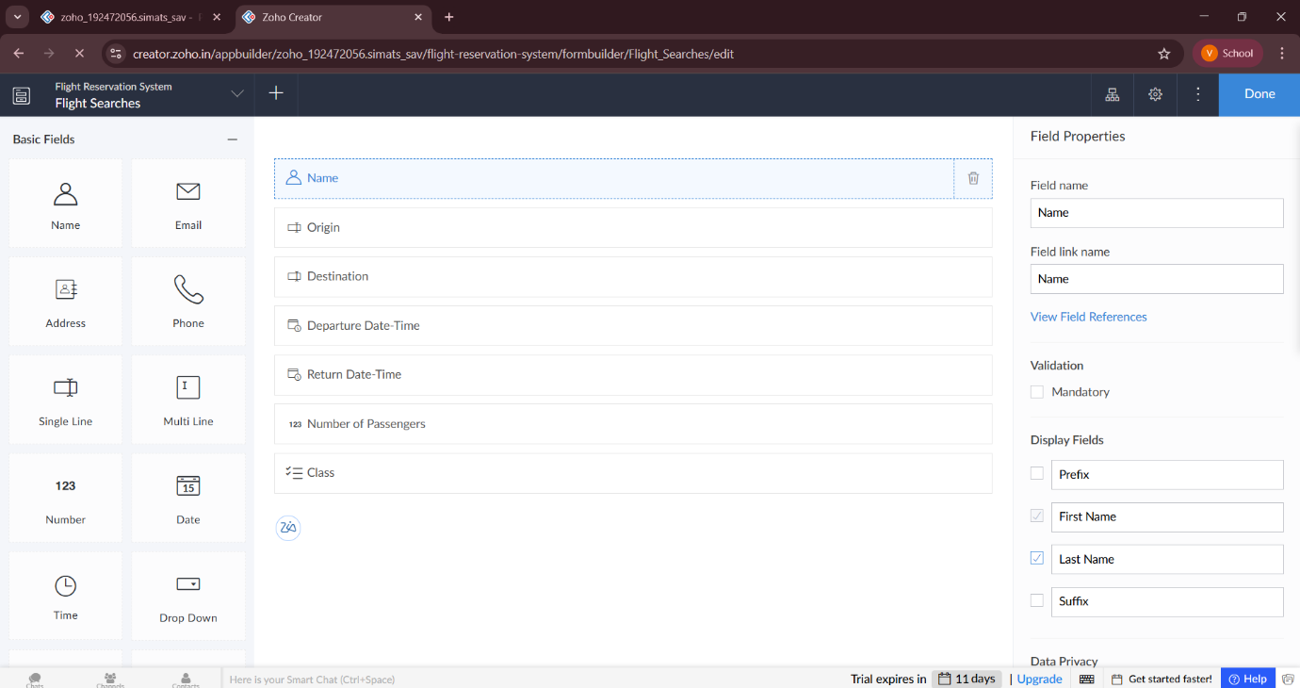

**FORM 2 –Passenger Details Form**

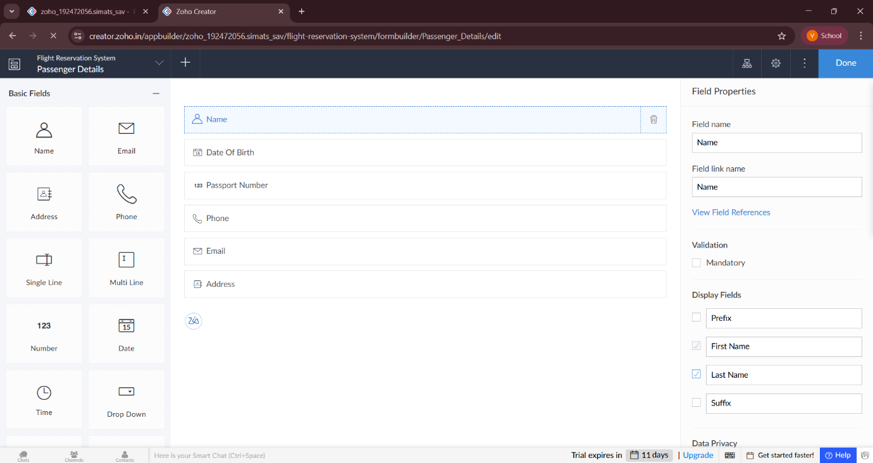

**FORM 3 –Payment Form**

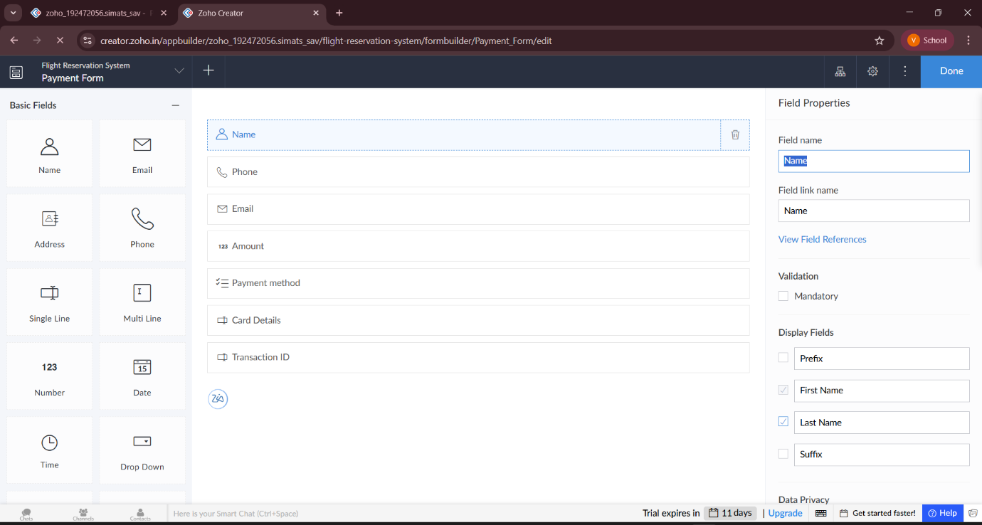

**FORM 1 – Flight Searches Form**

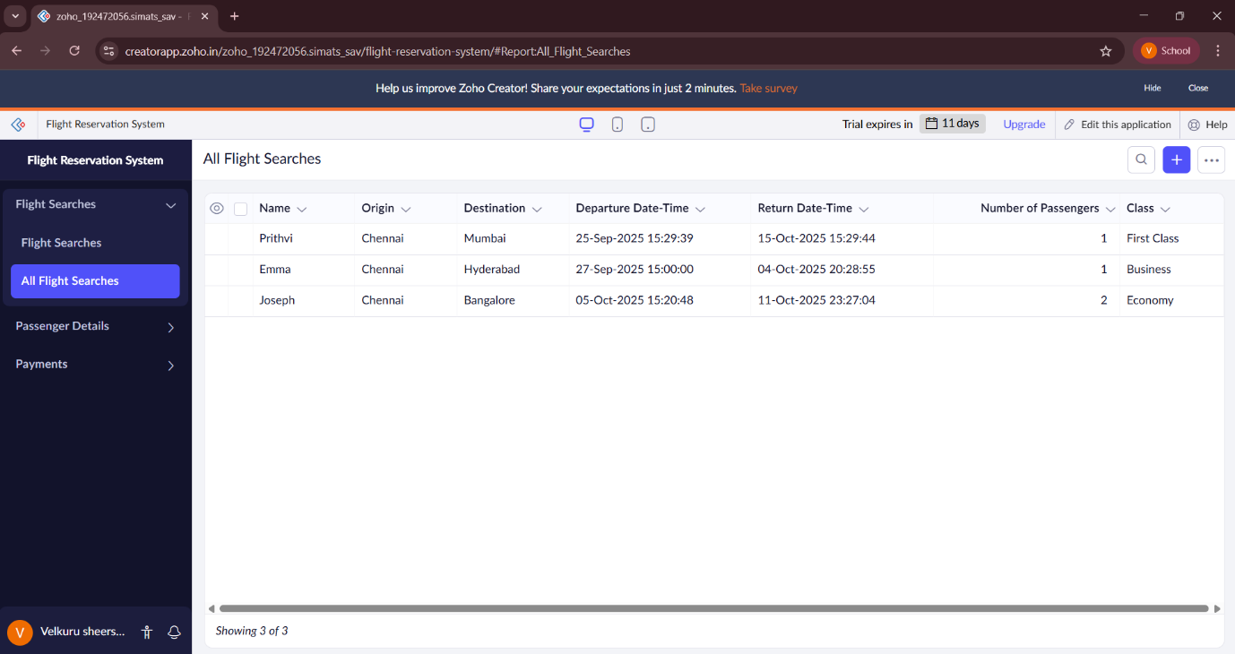

**FORM 2 – Passenger Details Form**

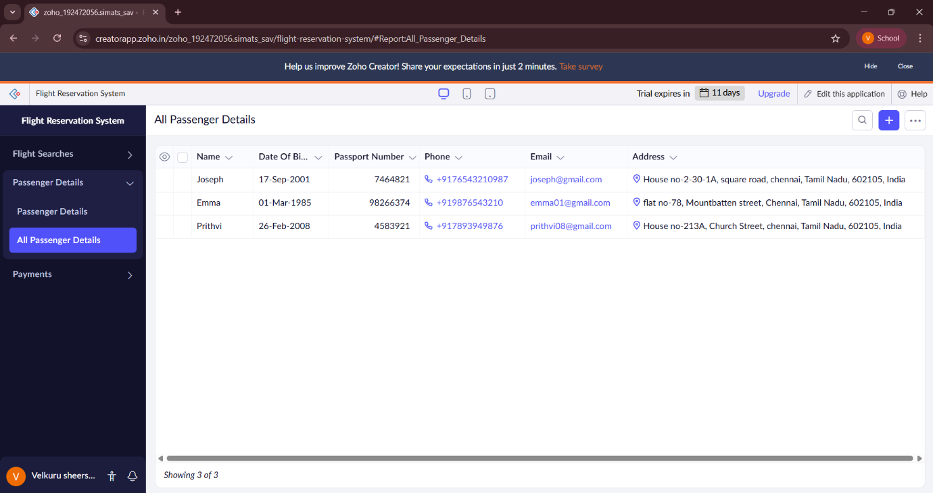

**FORM 3 – Payment Form**



**RESULT:**

A **Flight Reservation System** was successfully created using **Zoho Creator (Cloud SaaS platform)** with the following forms:

* **Flight Searches Form**
* **Passenger Details Form**
* **Payment Form**

This demonstrates **SaaS**, as users can register passengers, add flights, and make reservations entirely through the cloud without installing any software.